Assignment 1¶
- What are the differences between operators and values in the following?
* 'hello' -87.8 - / + 6
answer Operators:: +, -, *, / Values:: 'hello', -88.5, 5
- What is the difference between string and variable? spam 'spam'
answer :: string always get assigned to some variable,and always present in quotes.

3.Describe three different data forms.

answer:: str , int , float
- What makes up an expression? What are the functions of all expressions?
answer:: expression is made up of operators and variables . expressions are to assign the values to the
- In this chapter, assignment statements such as spam = 10 were added. Whats the difference between a declaration and an expression?
Answer :: declaration is uses to assign the type of variable. expression is use to evaluate.
- After running the following code, what does the variable bacon contain? bacon=22 bacon+1
answer :: the variable bacon will contain 22 cause after second statement the value is not assigned to the bacon

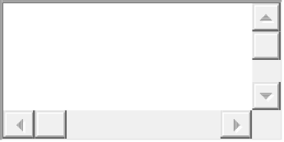
- What should the values of the following two terms be? 'spam'+'spamspam' 'spam'*3
answer:: both the terms will show output as 'spamspamspam'
- Why is it that eggs is a true variable name but 100 is not?
answer:: the name of variable cannot be the numerical value
- Which of the following three functions may be used to convert a value to an integer, a floating-point number, or a string?
answer:: the three functions are as follows int(), float(),str().
- What is the error caused by this expression? What would you do about it? "ihave eaten"+ 99 "buritos."
answer:: the error cause string cannot concatenated with int values

"i have eaten"+str(99)+"buritos."

